**Azure regions**

* Azure is made up of datacenters located around the globe.
* When you use a service or create a resource such as a SQL database or virtual machine (VM), you're using physical equipment in one or more of these locations.
* These specific datacenters aren't exposed to users directly. Instead, Azure organizes them into regions.
* some of these regions offer availability zones, which are different Azure datacenters within that region.

## Azure regions

* A region is a geographical area on the planet that contains at least one but potentially multiple datacenters that are nearby and networked together with a low-latency network.
* Azure intelligently assigns and controls the resources within each region to ensure workloads are appropriately balanced.
* When you deploy a resource in Azure, you'll often need to choose the region where you want your resource deployed.

***Important***

*Some services or VM features are only available in certain regions, such as specific VM sizes or storage types. There are also some global Azure services that don't require you to select a particular region, such as Azure Active Directory, Azure Traffic Manager, and Azure DNS.*

A few examples of regions are West US, Canada Central, West Europe, Australia East, and Japan West. Here's a view of all the available regions as of June 2020.

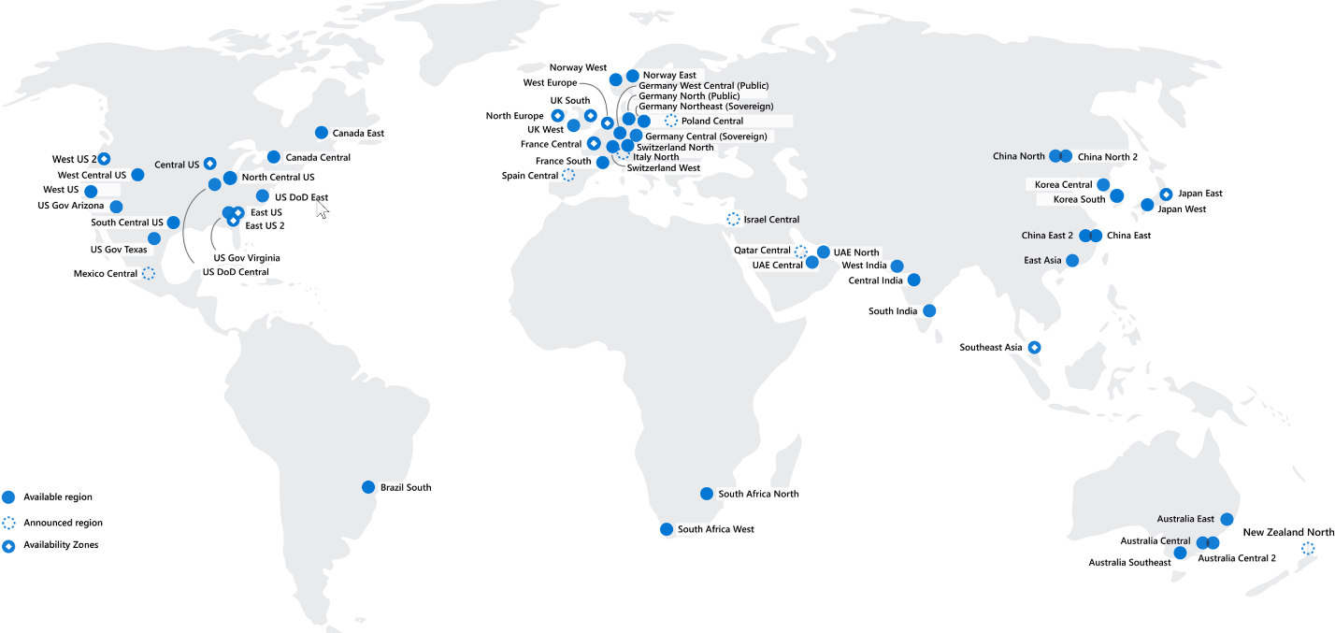

**Why are regions important?**

Azure has more global regions than any other cloud provider. These regions give you the flexibility to bring applications closer to your users no matter where they are. Global regions provide better scalability and redundancy. They also preserve data residency for your services.

**Special Azure regions**

Azure has specialized regions that you might want to use when you build out your applications for compliance or legal purposes. A few examples include:

* **US DoD Central, US Gov Virginia, US Gov Iowa and more:** These regions are physical and logical network-isolated instances of Azure for U.S. government agencies and partners. These datacenters are operated by screened U.S. personnel and include additional compliance certifications.
* **China East, China North, and more:** These regions are available through a unique partnership between Microsoft and 21Vianet, whereby Microsoft doesn't directly maintain the datacenters.

Regions are what you use to identify the location for your resources. There are two other terms you should also be aware of: geographies and availability zones.

# Azure Geographies

* Azure Geography is an area of the world that contains at one or more azure regions.

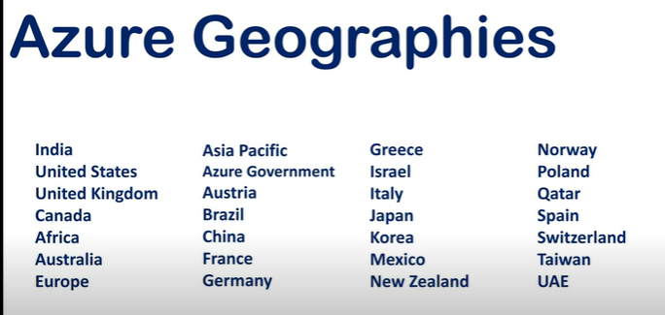

Why Geographies

* Regulated data like financial, health care or credit data may not be allowed to leave the country.
* Microsoft will not store customer data outside the geography you specify.
* Azure Geographies: <https://azure.microsoft.com/en-us/global-infrastructure/geographies/>